Assignment 2: SQL INDIVIDUAL PROJECT (10%)

Name: Vinh Nguyen (ID 1029531)

/*

1. List the full names (e.g. Alice Smith), as one column, of the users who have not taken any Steps yet. (1)

*/

SELECT CONCAT(first_name, ' ', last_name) AS full_name

FROM user

WHERE id NOT IN (SELECT DISTINCT user_id FROM step_taken);

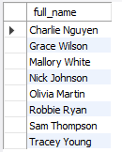

8 row(s) returned

/*

2. List all of the IDs and titles of Steps that contain the substring ‘mindful’ in their title. (1)

*/

SELECT id, title

FROM step

WHERE title LIKE '%mindful%';

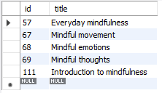

5 row(s) returned

/*

3. Provide a list of the titles of all Steps completed by user with id = 17. Do not show duplicates (list each title only once). (2)

*/

SELECT DISTINCT title

FROM

# Step IDs completed by user with id = 17

(SELECT DISTINCT step_id

FROM step_taken

WHERE user_id = 17 AND when_finished IS NOT NULL) AS step_user17

LEFT JOIN step

ON step_user17.step_id = step.id;



16 row(s) returned

/*

4. Provide a list of the titles of all Steps that have been taken more than two times along with a count of how many times. (2)

*/

SELECT step.title, popular_step.step_count

FROM

# Steps that have been taken more than two times

(SELECT step_id, COUNT(id) AS step_count

FROM step_taken

GROUP BY step_id

HAVING step_count > 2) AS popular_step

LEFT JOIN step

ON popular_step.step_id = step.id;



11 row(s) returned

/*

5. Which Step(s), listed with columns id, title and the count of times taken, have been taken the greatest number of times? (3)

*/

SELECT most_popular_step.step_id, step.title, most_popular_step.step_count

FROM

# Step IDs taken the greatest number of times

(SELECT step_id, COUNT(id) AS step_count

FROM step_taken

GROUP BY step_id

HAVING step_count =

# Max count

(SELECT COUNT(id) AS step_count

FROM step_taken

GROUP BY step_id

ORDER BY step_count DESC

LIMIT 1)

) AS most_popular_step

LEFT JOIN step

ON most_popular_step.step_id = step.id;



1 row(s) returned

/*

6. List each Step with the title column, along with a count of how many times that Step has been taken and the average

rating received by the Step (formatted to 2 decimal places). Order the result by the average rating as a number in

descending order. (3)

*/

SELECT step.title, average_rating.step_count, average_rating.avg_rating

FROM

# how many times a Step has been taken and the average rating received by the Step

(SELECT step_id, COUNT(id) AS step_count, FORMAT(AVG(rating), 2) AS avg_rating

FROM step_taken

GROUP BY step_id) AS average_rating

RIGHT JOIN step

ON average_rating.step_id = step.id

ORDER BY average_rating.avg_rating DESC;

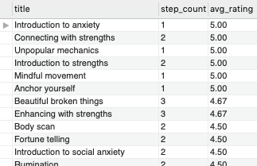

49 row(s) returned

/*

7. Provide a list of the titles of all Steps that have been taken by both Alice (id = 1) and Bob (id == 2), along with the

combined number of times they have taken the Step. (4)

*/

SELECT step.title, user_1_2.step_count

FROM

# Step IDs and times taken by both user id 1 and user id 2

(SELECT step_id, COUNT(id) AS step_count

FROM

# Steps taken by either user id 1 or user id 2

(SELECT *

FROM step_taken

WHERE user_id IN (1, 2)) AS user_1_2

GROUP BY step_id

HAVING COUNT(DISTINCT user_id) = 2) AS user_1_2

LEFT JOIN step

ON user_1_2.step_id = step.id;

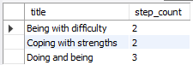

3 row(s) returned

/*

8. List users older than or equal to 21 years of age, along with a count of how many other users they are following

and a count of how many other users are following them. List the user’s id, first name, last name, age, following

count and followed count, and order the results by first name ascending, then last name ascending. (4)

*/

SELECT follow_21.*, COUNT(user_follow.following_user_id) AS followed_count

FROM

# Following count included

(SELECT follow_21.*, COUNT(user_follow.followed_user_id) as following_count

FROM

# Age >= 21

(SELECT id, first_name, last_name, TIMESTAMPDIFF(YEAR, DOB, CURRENT_TIMESTAMP) AS age

FROM user

WHERE TIMESTAMPDIFF(YEAR, DOB, CURRENT_TIMESTAMP) >= 21) AS follow_21

LEFT JOIN user_follow

ON follow_21.id = user_follow.following_user_id

GROUP BY follow_21.id) AS follow_21

LEFT JOIN user_follow

ON follow_21.id = user_follow.followed_user_id

GROUP BY follow_21.id

ORDER BY follow_21.first_name ASC, follow_21.last_name ASC;

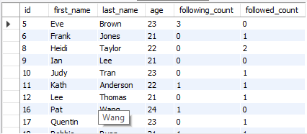

10 row(s) returned

/*

9. For each (user, theme) pair such that user has taken some steps under the theme, provide a count of how many times

a user has taken a step that is categorised under the theme. The output should consist of user ID, user first name,

user last name, theme name and the count of steps taken. (5)

*/

SELECT user_theme.user_id, user.first_name, user.last_name, theme.name AS theme_name, user_theme.step_count

FROM

# user_id|theme_id|step_count

(SELECT step_taken.user_id, step_theme.theme_id, COUNT(step_taken.id) AS step_count

FROM

step_taken

INNER JOIN step_theme

ON step_taken.step_id = step_theme.step_id

GROUP BY step_taken.user_id, step_theme.theme_id) AS user_theme

INNER JOIN user

ON user_theme.user_id = user.id

INNER JOIN theme

ON user_theme.theme_id = theme.id;

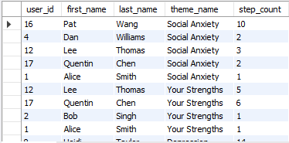

42 row(s) returned

/*

10. A) Provide a complete list of all user ID pairs such that the two users follow each other and share at least one

interest. (Hint: MySQL has a CROSS JOIN operator, which returns the Cartesian product of rows from the joined

tables) (5)

*/

SELECT pair.*

FROM

# Users follow each other

(SELECT uf1.following_user_id AS user_id1, uf1.followed_user_id AS user_id2

FROM

user_follow AS uf1

CROSS JOIN user_follow AS uf2

WHERE

uf1.following_user_id < uf1.followed_user_id

AND uf2.following_user_id > uf2.followed_user_id

AND (uf1.following_user_id, uf1.followed_user_id) = (uf2.followed_user_id, uf2.following_user_id)

) AS pair

INNER JOIN user_interest AS ui1

ON pair.user_id1 = ui1.user_id

INNER JOIN user_interest AS ui2

ON pair.user_id2 = ui2.user_id

GROUP BY pair.user_id1, pair.user_id2

HAVING SUM(ui1.interest_id = ui2.interest_id) >= 1;



1 row(s) returned